Kevin Arreola
3/29/20
Capstone
UML Behavioral diagrams

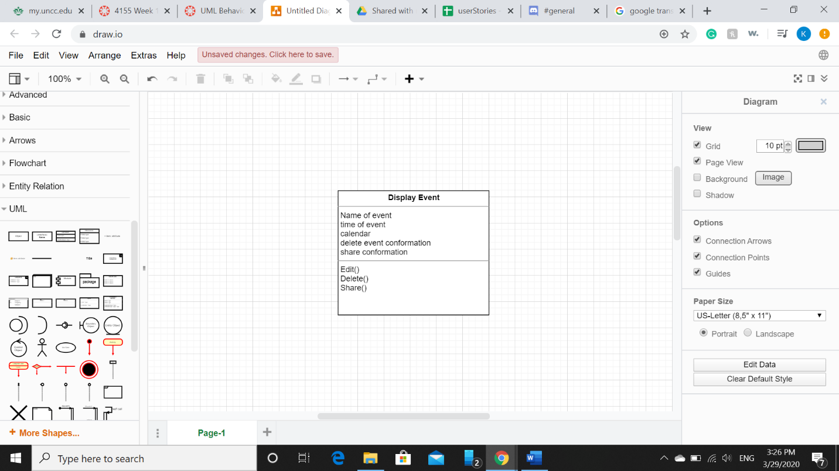

This diagram is the class diagram for the display events class. This class with contain everything that the user needs when they click on my events page. What this class will have when the display page comes up is the option to edit, delete, and share the event. The class will also contact the attributes (name, time, calendar, delete conformation, and share conformation). These values are the main features that will control what the user wants to do with the event

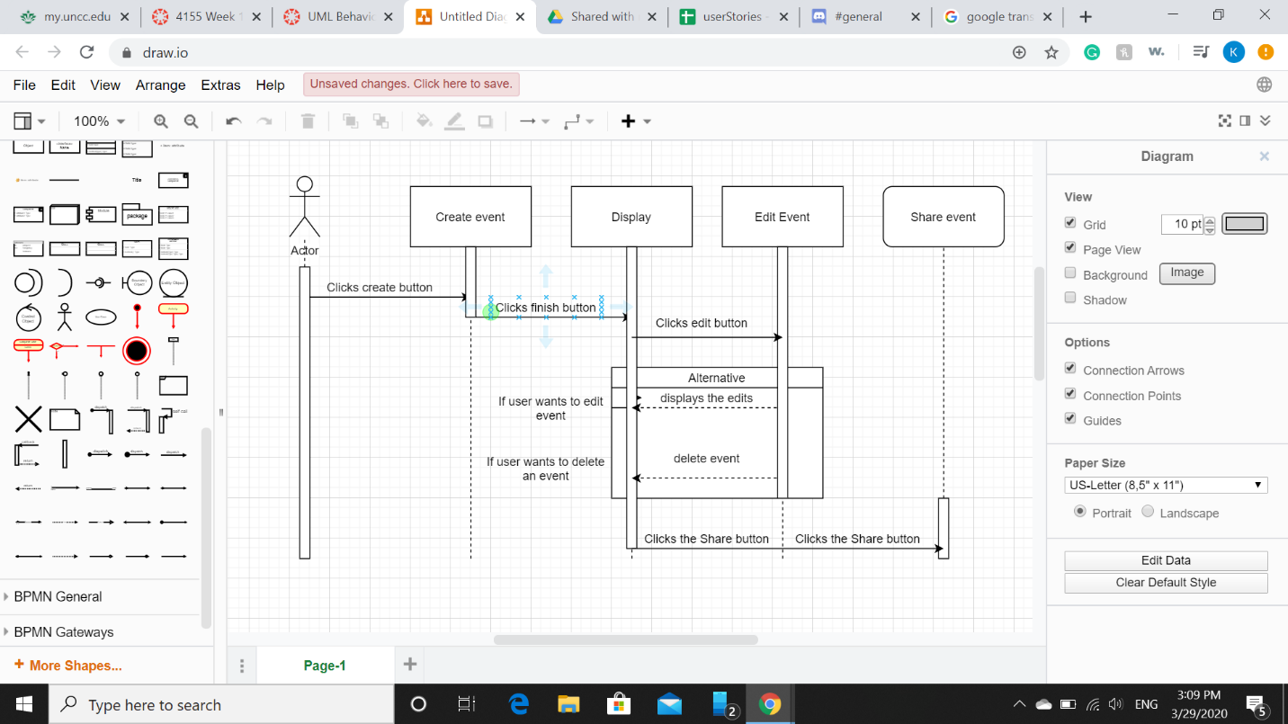

The sequence diagram shows above explains how the user will interaction with each feature of the class. When the use first interacts with my events page there will be nothing but create a new event button on the page. This is where the user can create new events and it will be display on this page. Once the user creates the event, he will also have the option to edit or share the event. If the user wants to edit the event, they can click the button and input the correct information or delete it entirely. Once the user finish editing, they can share the event if they want to. If there are no edits needed then the user can share the event if they choose to.

